MGST 631 L01 PRESCRIPTIVE ANALYTICS IN BUSINESS
PRESCRIPTIVE ANALYTICS FOR PEDESTRIAN COLLISION AVOIDANCE: MULTI-ARMED BANDIT OPTIMIZATION FOR ZOOX SAFETY TESTING
BRIAN NGUYEN
UCID 30302203

- Problem Definition: Autonomous vehicle (AV) safety remains one of the most critical challenges in mobility innovation. Public trust in fully autonomous transportation depends not only on technical performance, but also on transparent, data-driven safety processes. In October 2023, Cruise LLC became the subject of a U.S. Department of Justice investigation for misrepresenting details related to a pedestrian collision U.S. Department of Justice, 2023). This incident had widespread repercussions across the AV industry, prompting renewed scrutiny around rate but catastrophic pedestrian-related events.

For Zoox—a competitor in the Level 4 autonomous mobility space—the event served as the impetus for an internal reassessment of edge-case testing. Beginning in early-2024, the company launched an expanded pedestrian-safety evaluation campaign, with particular focus on scenarios involving occluded pedestrians, downhill grades, and unexpected prone obstacles. One high-risk scenario identified early in the campaign involved a Zoox robotaxi cresting a hill and suddenly encountering a prone mannequin lying perpendicular to the lane on a 9-degree downhill slope (AB Dynamics, 2022). Because of gravity and reduced reaction time at the crest, the question of which evasive maneuver is safest at different speeds became central (please refer to Appendix A).

Therefore, the decision problem is the following:

Given an unexpected prone pedestrian in the vehicle’s path, which evasive maneuver—Brake Hard, Swerve Left, or Swerve Right—minimizes expected harm across varying speeds?

This is inherently a prescriptive analytics problem. Traditional descriptive analysis can tell us what happened in similar events, and predictive models may forecast the likelihood of stopping or swerving success, but prescriptive analytics identifies the optimal action under uncertainty.

The scenario resembles a one-shot decision with uncertain outcomes: each maneuver has probabilistic success and catastrophic-failure modes (e.g., secondary collisions when swerving). This structure aligns directly with multi-armed bandit (MAB) models, where each “arm” represents an action with unknown reward distribution. The objective is to learn, through repeated trials, which action yields the highest expected safety payoff.

A MAB framework is appropriate for three reasons:
- Single-step decision – Unlike continuous trajectory planning, the evasive maneuver must be chosen immediately, making a bandit model suitable.
- Uncertainty in outcomes – Success or failure of braking or swerving cannot be known ahead of time but can be learned empirically.
- Limited real-world data – Catastrophic events are extremely rare; simulating allows the scalable exploration of the decision space.
The project, therefore, applies prescriptive analytics—in the form of a reinforcement-learning bandit model—to determine the optimal evasive action across three speeds (25, 35, and 45 mph), reflecting realistic operating domains of Zoox vehicles on urban roads (Sutton and Barto, 2018).

- Formulation: The prescriptive framework as a multi-armed bandit optimization problem where each action corresponds to a distinct evasive maneuver. The system must choose one action in each simulated encounter, observe the outcome, and update its expectations of the action’s safety.

Decision Variables:

Decision Variables and Definitions
Variable | Description
a | Chosen evasive action (Brake Hard, Swerve Left, Swerve Right)
s | Vehicle speed (25, 35, or 45 mph)
Q(s,a) | Expected reward (safety score) for taking action a at speed s.

a∈{Brake Hard, Swerve Left, Swerve Right}

For modeling purposes, each action is encoded as an integer (0, 1, 2).

Downhill braking difficulty and swerve reliability assumptions are consistent with AV operational literature (NVIDIA, 2023)

Environment Parameters

The following probabilistic parameters govern the simulation environment:

- Stopping probability decreases with speed and grade.
- Swerve success probability depends on maneuver dynamics and road geometry.
- Perception success probability captures small but non-zero human-like system errors.
- Impact severity penalties represent catastrophic outcomes (e.g., -700 reward for an impact because the AV was traveling too fast. -1000 reward because the AV did not perceive the agent and proceeded to make impact).
- NoGo penalties represent operational refusal to execute an action.
These parameters are chosen to reflect realistic AV performance and to heavily penalize unsafe outcomes, consistent with safety engineering priorities.

Reward Structure
The reward function encodes both the severity of outcomes and Zoox’s safety priorities:
- +100 for accurate perception
- +50 for successful emergency braking
- +20 for successful swerves
- –1000 for catastrophic impact with perception failure
- –700 for impact despite maneuver
- –100 for failed stop
- –20 for safe but unnecessary swerve
- –50 for NoGo conditions
Therefore, the objective is the following:
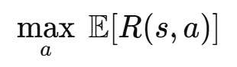

Learning Method: Epsilon-Greedy Multi-Armed Bandit

The agent uses an ε-greedy policy with ε = 0.1:
- 10% of the time – Explore a random action
- 90% of the time – Exploit the best-known action.
The agent maintains Q-values for each (speed, action) pair:
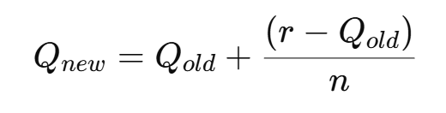
where n is the number of times the action has been executed at that speed.
The learning process updates Q-values after each simulated encounter, following the incremental update rule widely used in reinforcement learning (Sutton and Barto, 2018). The decision structure intentionally mirrors how AV systems must choose a maneuver immediately upon detecting a hazard.

- Data And Solution:

Data Constraints
Real-world AV pedestrian collision data is scarce and ethically constrained (Karla and Paddock, 2016); therefore, simulation provides the only scalable method for evaluating rare but safety-critical edge cases.
The model uses synthetic, physics-informed parameters that align with industry-standard pedestrian target models (AB Dynamics, 2022) and AV perception system performance ranges (NVIDIA, 2023). They include the following:
- Downhill braking difficulty
- Lateral-slip risks during swerves
- Varying perception accuracy
- Increasing deceleration demands at higher speeds
All simulation logic—including parameter definitions and Q-value updates—is documented in the accompanying Jupyter Notebook (Nguyen, 2025).

Simulation Design
The experiment simulates 3,000 mannequin encounters, each consisting of:
- Random selection of one of three speeds (25, 35, 45 mph)
- Action selection via ε-greedy policy
- Outcome resolution (perception success, brake/swerve success, impact, secondary impact)
- Reward assignment
- Q-value update
Cumulative rewards and Q-values are tracked over time.

Implementation
The solution was implemented in Python via a custom SafetyMAB class and an EpsilonGreedyAgent. The code executes all trials, logs outcomes, updates Q-values, and visualizes the cumulative reward.
Although the code does not appear in this main written report, it is fully documented in the accompanying Jupyter Notebook submitted as an appendix artifact.

Solution Outcome
Across all speeds, Q-values converged to a ranking where Brake Hard was consistently the highest-reward action. This result emerges despite increased braking difficulty at high speeds due to the severe penalties associated with failed perception and secondary collisions during swerves.

- Analysis:

Learned Optimal Policy
After 3,000 trials, the model’s optimal evasive action for all tested speeds was:
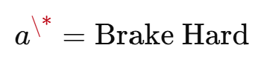
The learned optimal policy of Brake Hard across all speeds is consistent with the safety-first reward structure and the high penalties associated with catastrophic perception failure—an effect that is documented in reinforcement learning literature on reward shaping (Sutton and Barto, 2018).
This finding reflects the interaction between:
- Moderately reliable braking
- Relatively unreliable swerving
- Extremely high catastrophic penalties for impacts
- The compounding effect of perception failures

Interpretation
At 25 mph, braking provides high probability of avoiding impact.
At 35 mph, braking remains slightly more reliable than either swerve, and secondary-impact risks dominate swerve outcomes.
At 45 mph, although braking success worsens, the catastrophic penalties from failed swerves outweigh the risks of braking.
As a result, braking produces the highest expected safety payoff across speeds.

Sensitivity Analysis
Varying key parameters reveal several insights:
- Perception failure penalty has the largest influence on action ranking at high speeds.
- Swerve reliability strongly affects the tipping point where a swerve could outperform braking.
- Stopping probability sensitivity shows nonlinear effects: even small improvements greatly reduce expected harm.
- Increasing catastrophic penalties makes the model more conservative, reinforcing Brake Hard dominance.
The sensitivity analysis reveals conditions under which swerving might become optimal—primarily when lateral control reliability increases. Such observations mirror insights from AV testing frameworks, where lateral versus longitudinal control tradeoffs are well-known (NVIDIA, 2023).
The rarity and ethical constraints of real pedestrian collisions justify the simulation-based approach (Karla and Paddock, 2016).

Limitations
Several structural limitations must be acknowledged:
- Simplified action space: real Avs do not choose only among three discrete options.
- Synthetic parameters: although realistic, they do not reflect all physical nuances.
- Single-step decision assumption: real AV maneuvering is continuous and time-dependent.
- Reward values reflect informed engineering judgments, not medical injury models.
These limitations define the boundaries of applicability.

Business and Engineering Implications
For Zoox, the model offers several insights:
- Improving lateral control performance could make swerving safer.
- Enhancing perception reliability dramatically reduces catastrophic outcomes.
- Simulation-driven prescriptive analytics can guide safety prioritization.
- Reinforcement learning provides a framework for evaluating rare edge cases without requiring real-world incidents.
This supports Zoox’s internal safety-validation ecosystem following the Cruise Department of Justice scrutiny.

- Conclusion: This project demonstrates how prescriptive analytics—implemented through a multi-armed bandit reinforcement learning model—can help identify the safest evasive action for an autonomous vehicle encountering a prone pedestrian on a downhill grade. The methodology complements industry testing workflows involving soft pedestrian targets and scenario-based evalutations (AB Dynamics, 2022). By simulating 3,000 encounters across multiple speeds, the model learned that Brake Hard consistently minimizes expected harm under the modeled assumptions.

The findings reinforce the significance of:

- Robust perception
- Reliable braking systems
- Careful evaluation of swerve dynamics
- Simulation-driven policy assessments for safety-critical AV decisions.

Although this project uses a simplified reinforcement learning techniques, such as Q-value estimation and action-value policies, the model provides a valuable decision-support tool and a foundation for more advanced reinforcement learning or trajectory-optimization approaches (Sutton and Barto, 2018). Future work could extend this framework to continuous action spaces, incorporate richer sensor models, and validate outcomes against controlled real-world testing.

Appendix A
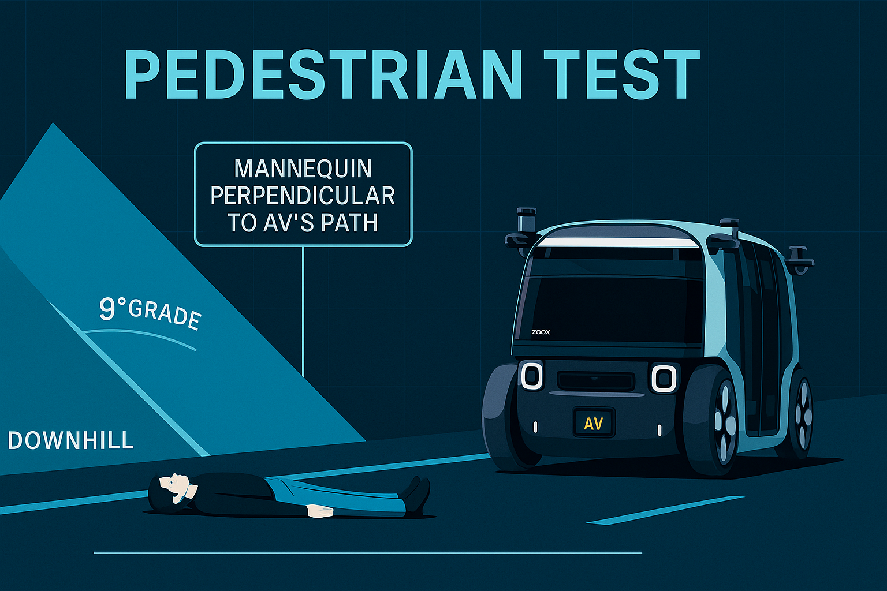

Appendix B – Full Reward Structure Table
Reward Structure Overview (Used for Optimization)
Outcome | Reward Value | Rationale
Perception success | +100 | High-value safety critical correctness
Successful stop | +50 | Positive outcome with minimal risk
Successful swerve | +20 | Safe but introduces small lateral risk
NoGo | -50 | Operational inefficiency/hesitation
Failed stop | -100 | Non-catastrophic but dangerous
Swerve secondary impact | -300 | Significant but non-fatal consequence
Impact despite maneuver | -700 | Swerve safety event
Catastrophic perception failure | -1000 | Most undesirable outcome

Appendix C – Parameter Definitions and Values
Environmental Parameters Used in Simulation
Parameter | 25 mph | 35 mph | 45 mph | Notes
Stopping probability | High | Moderate | Low | Models reduced braking performance downhill
Swerve success | Moderate | Moderate/Low | Low | Based on lateral control and slip risk
Perception success | ~0.97 | ~0.96 | ~0.95 | Slight degradation at higher speed
Catastrophic penalty | -1000 | -1000 | -1000 | Speed-independent but risk increases
Appendix D – Cumulative Reward Curve Over 3,000 Trials
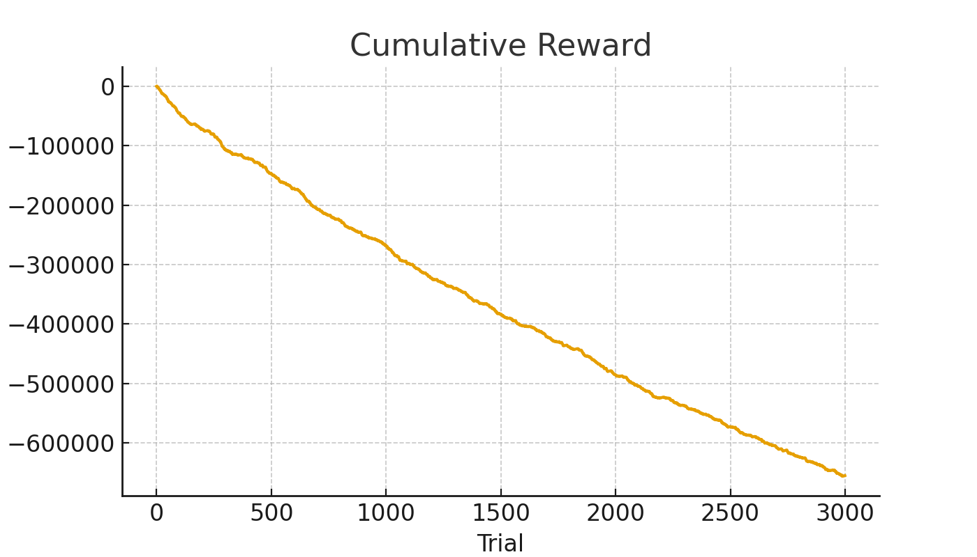

Appendix E – Python Simulation Overview (Summary Only)
- SafetyMAB environment class
- EpsilonGreedyAgent
- Trial loop for 3,000 AV-pedestrian encounters
- Q-value update logic
- The Jupyter notebook will be submitted separately

Works Cited
Cruise LLC. (2023). Cruise admits submitting false report to influence federal investigation and agrees to pay penalty. U.S. Department of Justice.
https://www.justice.gov/usao-ndca/pr/cruise-admits-submitting-false-report-influence-federal-investigation-and-agrees-pay
Sutton, R. S., & Barto, A. G. (2018). Reinforcement learning: An introduction (2nd ed.). MIT Press.
NVIDIA. (2023). Zoox autonomous robotaxi powered by NVIDIA DRIVE.
https://blogs.nvidia.com/blog/zoox-autonomous-robotaxi-powered-by-nvidia/
AB Dynamics. (2022). Soft pedestrian 360 ADAS testing target.
https://www.abdynamics.com/track-testing/adas-targets/soft-pedestrian-360/
Perturbation-based AV testing literature
Kalra, N., & Paddock, S. M. (2016). Driving to safety: How many miles of driving would it take to demonstrate autonomous vehicle reliability? RAND Corporation.
Nguyen, B. (2025). Prescriptive Analytics Capstone Project: Multi-Armed Bandit Simulation Notebook.
(Unpublished manuscript, University of Calgary).

